One Love Animal Rescue, Inc.

Foster Manual

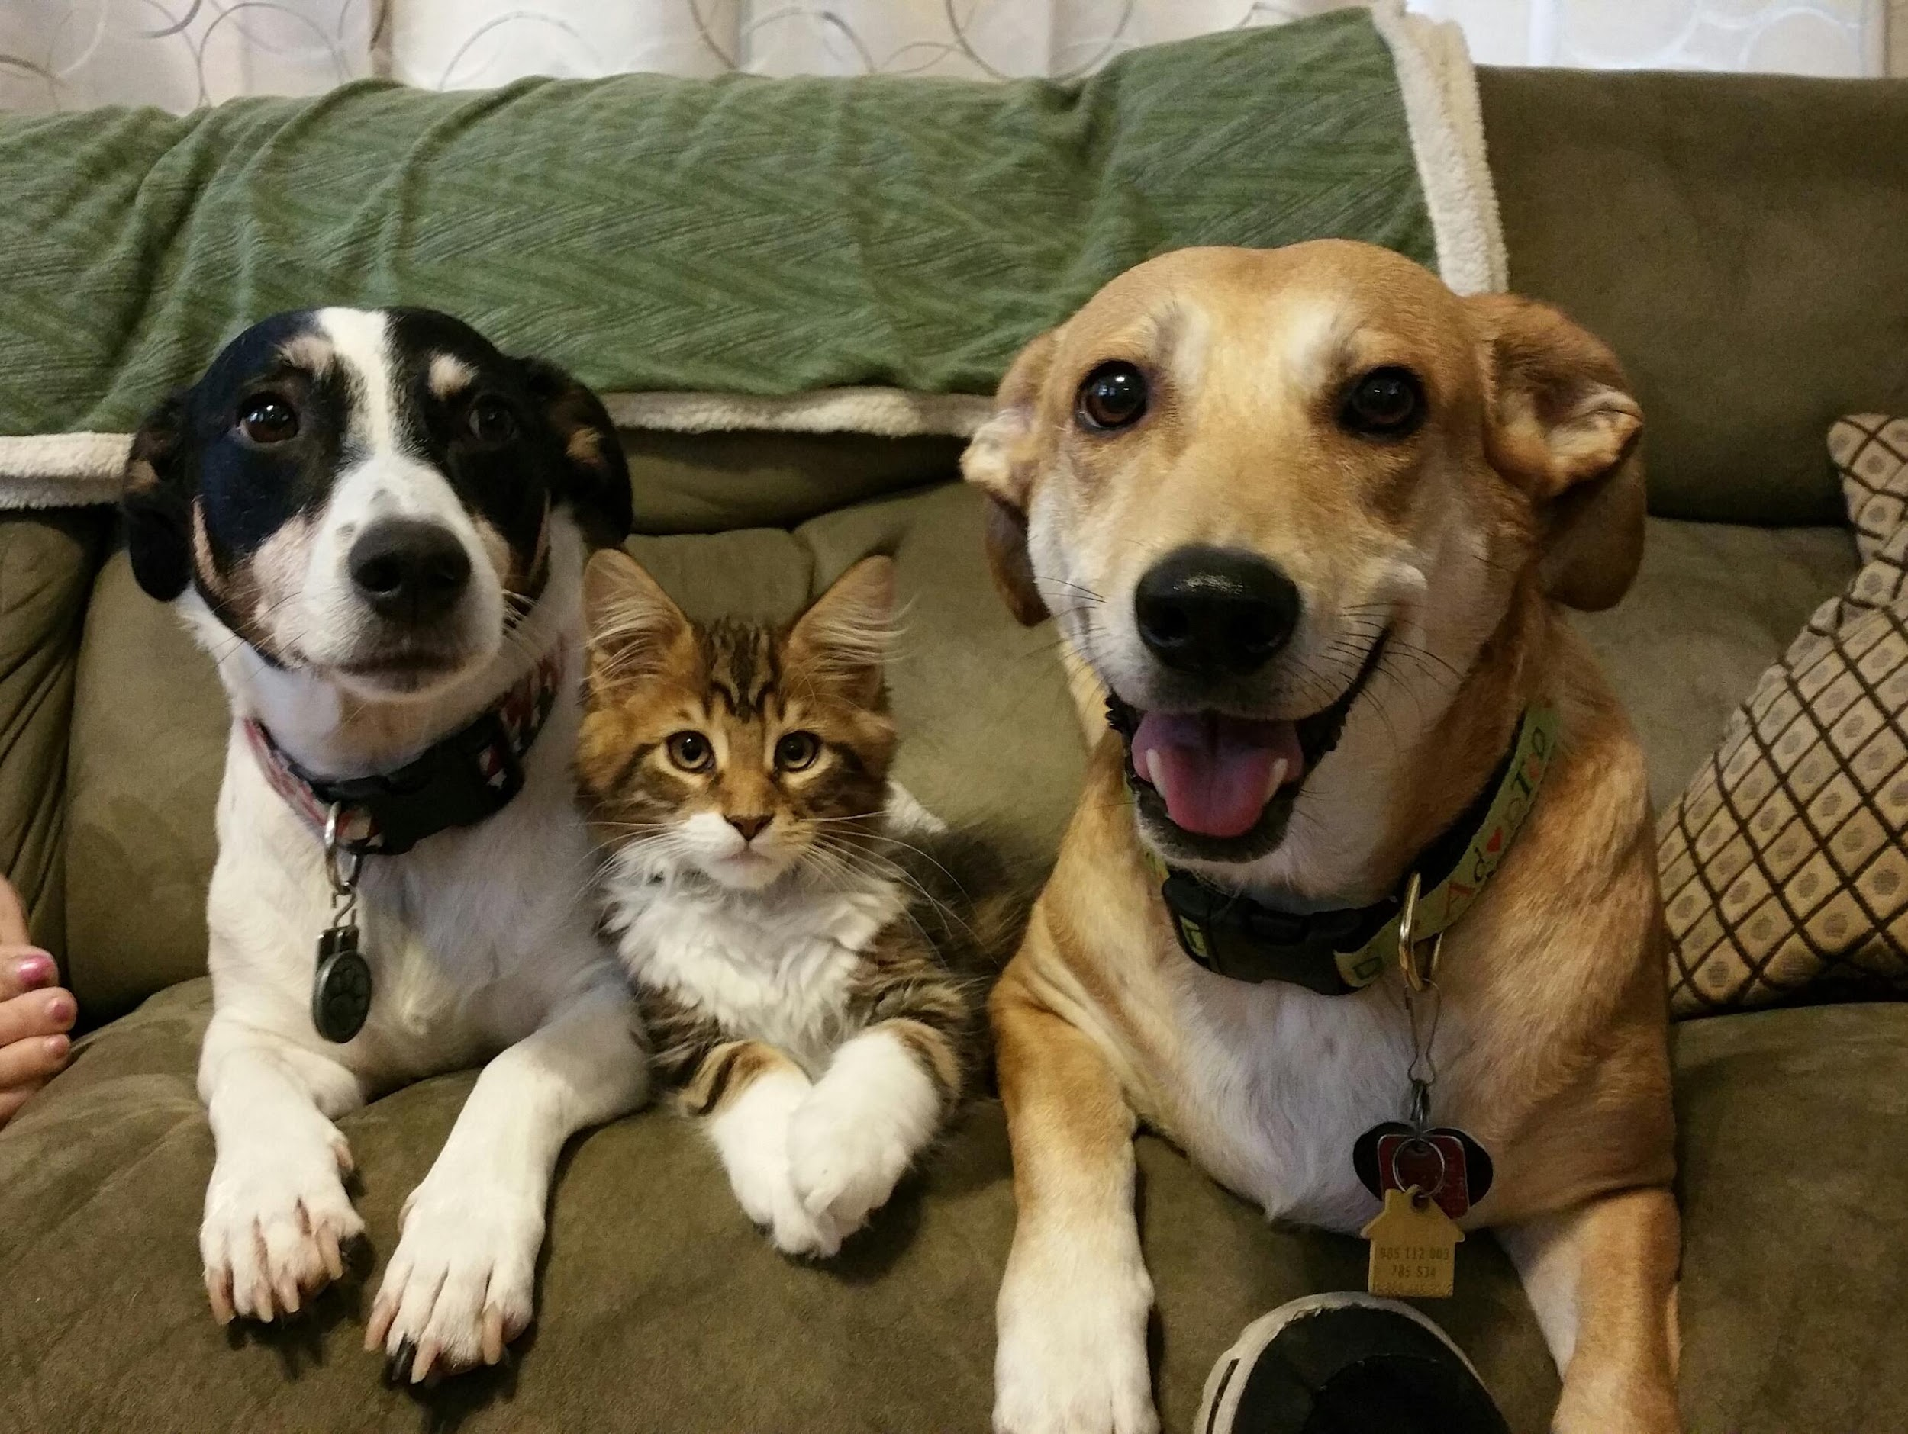

Mailing Address:
463 Johnny Mercer Blvd
Ste. B7 #142
Savannah, GA 31410
www.oneloveanimalrescue.com
Tax ID: 46-3370826

Table of Contents

TABLE OF CONTENTS .........................................................................................................................2

INTRODUCTION.....................................................................................................................................3

GENERAL GUIDELINES....................................................................................................................3-4

GETTING YOUR HOME & FAMILY READY FOR FOSTERING .............................................4-5
SUPPLIES ......................................................................................................................................................5

INTRODUCING YOUR FOSTER DOG TO YOUR HOME ..............................................................5
EVERYONE NEEDS THEIR SPACE ...................................................................................................................6
DOG INTRODUCTIONS ..................................................................................................................................6
GETTING ALONG ...........................................................................................................................................6
CAT INTRODUCTIONS....................................................................................................................................7

TRAINING WITH YOUR FOSTER DOG ........................................................................................8-9

DOGS & CHILDREN ..............................................................................................................................9

MEDICAL TREATMENT ....................................................................................................................10

ADOPTION PROCEDURE .............................................................................................................10-11

ADOPTION EVENTS .......................................................................................................................11-12
BEFORE THE EVENT ..............................................................................................................................11-12
TOP TEN THINGS A DOG HANDLER SHOULD KNOW …..............................................................................12

REIMBURSEMENT PROCEDURE ....................................................................................................11

APPENDIX .........................................................................................................................................13-17
EXPENSE REIMBURSEMENT FORM ..............................................................................................................15

Introduction
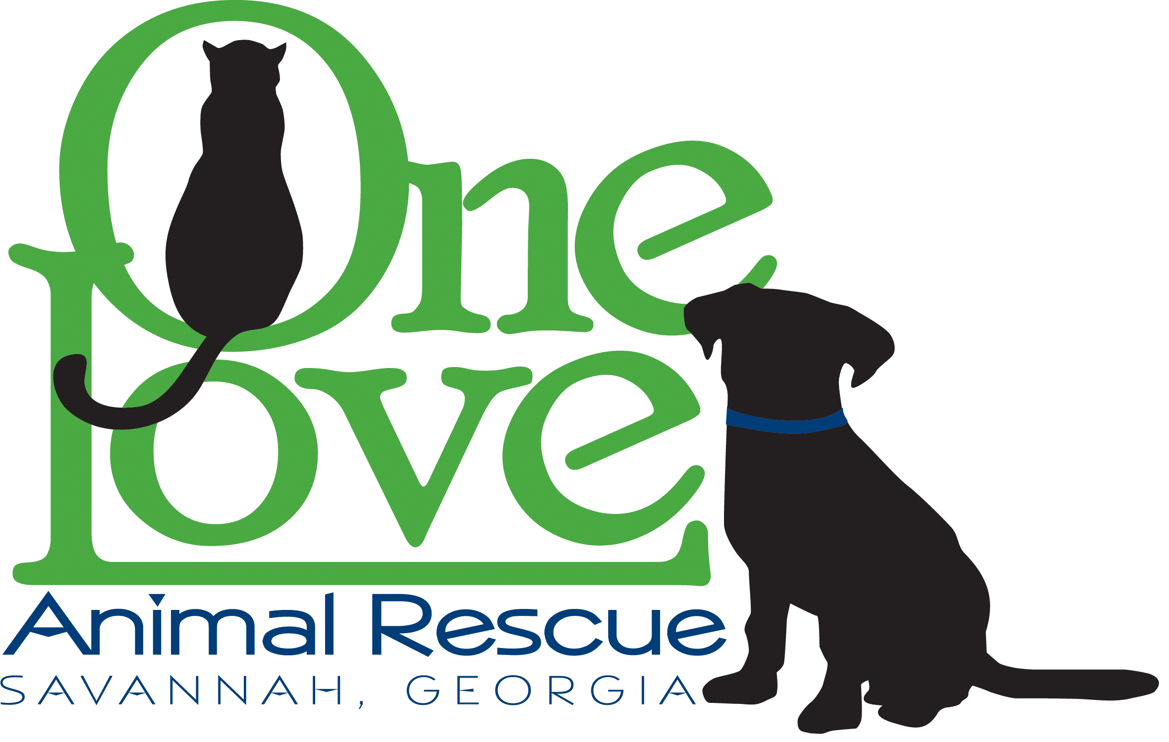
Thank you for being a foster home (“Foster Home”) for One Love Animal Rescue, Inc (“One Love”). Foster Homes like yours allow us to rescue more animals and we appreciate your generosity in opening your home to a rescued animal. By providing a foster home, you’re providing a stable, loving environment for an animal that may have been abused, neglected or abandoned. You’re also providing the much-needed socialization and basic training that will make our cats and dogs more appealing for adoption and better members of their adoptive families. One Love rescues cats and dogs from shelters and streets all over the Savannah area, as well as partners with rescue groups nationwide. Dogs must pass our temperament test in order to be pulled from the shelter and placed into a foster home. Only directors of One Love can determine which dogs our organization will accept. The animals we rescue are generally those that are in their last hours at the shelter and are at great risk of being euthanized.

General Guidelines

Please read & review the following important guidelines:

1. Prior to fostering, all Foster Homes must complete an online Foster Home Agreement and complete a home inspection. (See Appendix for Agreement)

2. All Foster Homes agree to accept primary responsibility for providing lodging and care for their foster cat or dog until a permanent adopting family is found.

3. One Love supports our foster animals 100% in vetting and supplies as long as the funds are available

4. Medical care must be provided by a One Love approved veterinarian. If your foster pet needs any medical care, including vet visits or over-the-counter medications, please contact your One Love President Karrie Bulski.

5. Foster Homes must agree to bring their foster pet to adoption events regularly, and at least twice per month. Foster Homes must also agree to be available for appointments where potential adopters can meet the foster pet upon request and reasonable notice. NEVER invite a potential adopter to your personal residence.

6. Foster Homes must agree to keep the One Love Foster Coordinator apprised of their foster pet’s behavior and if any issues arise.

7. If you are unhappy with your fostering situation, please notify the One Love Foster Coordinator immediately. One Love will work on relocating your foster pet as soon as possible. We appreciate your patience as we remedy the situation.

8. We do not foster-to-adopt. Potential adopters must still go through our regular application process.

9. All applicants wanting a particular foster pet must go through the One Love application process (application, interview by One Love Adoption Specialist and home visit). A friend or family member of the Foster Home who wishes to adopt your foster pet must go through the same process as other applicants.

10. Your own pets (including species other than cats or dogs) should be up to date with their vaccinations. We do recommend that you vaccinate your dogs with the Bordetella vaccination to prevent kennel cough—a common illness with shelter dogs.

11. One Love is not responsible for any veterinary bills for resident pets. The Foster Home assumes responsibility for the veterinary bills that result from resident pets becoming ill due to exposure with a foster pet or any injury resulting from but not limited to, an unpleasant interaction between your resident pet and foster pet (dog fight, scratches, etc.).

12. If you are planning a vacation, please notify One Love as far in advance as possible, but at least within two weeks of the vacation date. If you want to take your foster pet with you—even for just a weekend—you MUST notify One Love beforehand and receive approval. If One Love has an applicant interested in adopting, we may make arrangements to keep your pet locally with someone else in order to show him/her.

13. Do not leave your foster pet with anyone else without prior approval from One Love. Anytime a foster animal is left with someone outside of the Foster Home we MUST have a signed release of liability.

Getting Your Home & Family Ready for Fostering

Fostering is a commitment that will affect your entire household: your family, your permanent-resident pets, your house and even your yard! Here are some tips and questions you can answer to ensure that fostering will be a positive experience for you and your family:

Discuss your plans with family/household members beforehand and get their input on how to make the best decision for everyone.

Include in the discussion what kind(s) of dogs (or cats) are appropriate for your household: small/large, young/old, active/not active.

Do you thrive on a spunky dog with lots of energy who is a willing playmate for your active dog?

Do you have an older dog who would not appreciate being pestered?

How long are you gone during the day?

We’ll need to match you with a dog or cat that works with your schedule and your lifestyle, even if he/she is only a temporary resident. Your One Love Foster Coordinator can work with you to ensure that we understand your personal situation and what types of pets are appropriate for you.

Supplies

One Love will provide all supplies needed for your foster animal as long as funds are available but we do appreciate any donations. Supplies include:

 Food & Water Bowls: It is best to have separate bowls for your foster pet and resident pets, and to feed them separately so that they can eat in a stress-free environment as they are getting to know each other.

 Food & Treats: One Love will supply food or treats depending on the receipt of donations. Otherwise, we will advise you as to what kind of food and treats are best for your foster pet.

 Dog Crate: We strongly recommend you have a crate for your foster dog. Crate training is a very helpful way to introduce a dog into a new home. We can supply you with a crate if you do not have one. We can provide you some excellent articles on proper techniques of crate training if needed.

 Bedding: Cotton blankets, an old comforter or large beach towels are best as they are washable and less likely to be chewed up by your foster dog. This works well for cats, too.

 Toys: Kong toys are excellent dog toys for chewing as they can be stuffed with treats and will keep your foster dog occupied, especially while you are away from the house. Stuffed toys or balls are also great, depending on your dog’s temperament. Cat toys can be simple as well, as aluminum foil rolled into a ball. It can provide hours of entertainment for a cat. One Love may sometimes provide toys depending on our donations.

 Collar & Leash: We will provide a collar and leash for your dog. A One Love ID tag will be on your dog’s collar as well. This collar and tag should stay on at all times as it will help ensure that the dog is returned to One Love if the dog ever gets out and is picked up by the shelter. Cats should remain always indoors, but we suggest that they wear a collar and tag as well.

 Flea Treatment & Heartworm Prevention: One Love requires all dogs and cats to be on flea and heartworm prevention. We will work with each home to determine the best treatment method.

 Litter Box: It is completely necessary that all foster cats are brought into a home with appropriate “potty” areas. A litter box is needed, along with litter and cleaning supplies.

Introducing Your Foster Dog or Cat to Your Home

Here are some tips for a smooth transition when bringing a new family member into your home:
Note: These guidelines should be followed for foster cats as well.

Everyone Needs Their Space

If possible, it is best to keep foster dog(s) and resident dog(s) separate, as needed, from each other for the first two days. This is a stressful time for both dogs and keeping them separated can help the dogs become comfortable. Your foster dog may have been on the street, in the shelter, or in a transition foster home —a lot of change for an animal that likes to have a “pack” and some stability in his/her life! There are some common sicknesses that sometimes don’t show up for 1-2 weeks that dogs often get at the shelter, so early separation can help ensure that your resident dog(s) remains healthy.

If it is not possible to keep them separate, be aware that your dog(s) may be exposed to illness. However, also be aware that many of the diseases that shelter dogs get (kennel cough, diarrhea, etc.) are stress related and are easily remedied. Many have had poor nutrition and a hard life before coming to your home. One Love cannot be responsible for veterinary expenses for the resident dog(s). Try to ensure that each pet has its own personal space: a bed, a crate, or a special area that each pet knows is just for him/her. This will keep the stress levels lower for your own dogs and the foster dog.

The backyard is not an acceptable place to leave the foster dog alone and unsupervised. They may be destructive (digging, trampling plants), they may be escape artists, they may bark incessantly, or they
may be stolen. A crate or a room that is enclosed—like a kitchen or bathroom—is the best choice.

Dog-to-Dog Introductions

Introduce your resident dog(s) to the foster dog on neutral territory, such as a park or down the street from your house. Introduce them on leash, with an adult holding each leash. Allow a quick “hello” sniff or walk-by, and then separate them—even if things seem fine. This gives them a chance to think about things, and often they will seek each other out for a lengthier greeting. Give lots of positive reinforcement so that both dogs feel safe and that the other dog is a friend, not a foe.

If one dog becomes aggressive, separate them quickly, comfort the dogs, and slow down the pace of the introductions. Don’t force things if they are not immediate best friends, as it sometimes takes a few days for dogs to accept each other. By giving them each attention separately, and making them feel safe about their bed, toys, and food, you can minimize any tension that may arise.

Getting Along

Dogs are pack animals meaning there is usually one who dominates, whereas the others tend to follow the lead. Correction of one dog by another (whether it is your resident dog or the foster) is normal. As long as the dogs are responding positively to each other and seem to recognize the “pecking order,” this is fine. So, one dog may growl at another. If the dog reacts by moving away or showing passivity then usually, the dogs will get along fine. If they are constantly battling for the “alpha” position, then they will have to be separated and this means they may not be a good fit for each other. Never leave the dogs unsupervised together. They are still getting to know one another and will need correction on appropriate dog-to-dog behavior, which means supervision is extremely important. If you are leaving the house, then crate each dog or otherwise physically separate them. Again, please remember to feed the dogs separately. This reduces stress for everyone. Food aggression between dogs is common.

Cat-to-Cat Introductions

Cats may be introduced first through a closed door, where they can sniff under the door for a day or two. You may want to take a towel that the foster cat has been sleeping on to let the resident cat get accustomed to the scent. When you decide to make a personal introduction, your resident cat should be reaffirmed that he or she is still the top cat, which means that your attention is not diverted to the new arrival. Just like with dogs, giving them separate space to sleep and eat can be tremendously helpful in easing the tension while making these adjustments.

Foster cats should remain indoors at all times.

Cat-to-Dog Introductions

First, make sure that your cat has his/her own sanctuary, preferably a room where the foster dog will not be allowed to go. If you can, keep the cat’s food & litter box in this room, and the door closed. The dog and cat can sniff each other under the door for a few days before meeting face to face. This will make things go a lot smoother, as they will feel they have already “met.” Supervise the dog’s behavior even at the door and reinforce playful, curious behavior while correct any aggression or obsession.

This process is to be applied to introducing a foster cat to a resident dog. Make sure that the cat has a sanctuary where the dog is to not access.

When introducing the dog and cat for the first time, put the dog on a leash and just allow the cat to walk by. You should evaluate responses of both the dog and the cat. Is the cat fearful or curious? Is the dog happy and playful or lunging at the cat? Long stares from the dog can also be of concern. If this happens, break the dog’s stare immediately, and continue with the introduction.

After introductions have occurred, keep in mind the following tips:

Never leave the cat & foster dog unsupervised, even if it looks like they get along great. A playful dog can still unintentionally harm a cat.

Make sure your cat has several places to jump up or hide under where the dog can’t reach him/her.

Playful chasing is normal, but always remind the foster dog to play nice, and be gentle.

Don’t allow the dog to stare down the cat.

The cat may swipe at the dog or hiss in order to correct. This is usually a great help in ensuring that the dog knows his/her place. However, please keep an eye on interactions to ensure that the cat doesn’t injure the dog.

With all your resident pets, allow the animals to accept one another on their own time. Never push them toward each other or force interaction. Many animals become companions and playmates, while others simply tolerate each other.

Training with Your Foster Dog

While your foster dog is living with you, you can provide some basic training along with lots of tender loving care. No formal training regime is needed for most foster dogs, but if you can work on the following, it will make your foster dog much more “adoptable.”

 Socializing is definitely the first priority. This means ensuring that your foster dog is acclimated to meeting new people, dogs, cats, children, etc. If you have a shy dog, this can be a big task for some Foster Homes. This type of situation should be approached slowly (but all the more important to address it so that your dog overcomes his/her shyness.) With an outgoing dog, it’s more about curbing enthusiasm so that people aren’t overwhelmed upon meeting the dog or put into a situation with being knocked over with love!

Food aggression with rescue dogs, this can be a fairly common trait; however, food aggression towards people is not acceptable. If your foster dog is growling when you are near his food, you need to work on correcting this behavior.
- First, pretend to ‘eat’ some of the food yourself, which cues the dog that you are the pack leader.
- Next, hand-feed the dog, so that it’s clear the food is yours, and you are the giver of food.
- Then, when feeding with a bowl, take it away several times during the meal, giving it back after the dog sits and waits politely.

With a non-food aggressive dog, these are still good tips, along with taking chew toys and bones away and giving them back. If the dog growls a bit tell him “no” and then practice taking it until they get the idea. Repeat daily. If your foster dog is showing food aggression with your resident dog over food or chews, always feed them separately. This is another good reason to crate your foster dog, as you can use that place as a safe place to give treats, chews, and toys.

 House training (potty training) is desirable for both you and the future adopter. The best way to house train is to use a crate, and to be vigilant about taking the dog outside regularly, including
after naps and meals. If a dog is particularly stubborn about house training, keep him/her on a leash in the house; this will prevent wandering off to hide to go potty.

 Crate training is a great way not only to potty train, but also to establish general house manners since the dog will not be roaming free in the house unless he/she is being supervised. For example, there will be no chewing on couch cushions, counter-surfing, or garbage can diving if the dog is not left alone.

 Sitting is relatively easy to teach and pays big dividends. A dog that sits for his/her leash, food and petting knows they are subservient to the person commanding them to sit. It also helps to get an overly excited dog under control. Remember that dogs don’t speak English, so they will learn the action before they learn what the word means. You can usually lure a dog into a sit by letting him/her get a good whiff of a treat, then raising it above the head/ nose. It is only when the behind hits the ground that he is rewarded with the treat. The word is added later as a command.

 Jumping up is a common problem with our foster dogs—they are so happy to have someone to love! But, it’s best if they are taught not to do this, as it can be dangerous. The best prevention is to see it coming and tell them to sit, if they have learned this command. Members of the Foster Home and guests should all be trained to turn away from the dog if he/she starts to jump. Pushing the dog down only serves to reinforce the jump, as hands and attention are what the dog seeks. No hands and no attention until all paws are on the ground!

 Leash walking is challenging to teach. Many of our dogs have never been on a leash and have no idea how to behave. If you’re ambitious, you can work on “heel”, but even “easy” is fine. “Easy” is
when the dog isn’t necessarily heeling at your side, but they are also not dragging you down the street. This takes time to learn and patience on your part. A nervous dog may not be pulling but is reluctant to walk or try to get away from you and the leash. The goal is to get the dog to relax and walk confidently with you. One Love can give you some pointers on either of these cases.

 Squirt bottles can be a great way to get the point across to a dog that is not responding to a verbal correction. Fill a squirt bottle with plain water, and set the nozzle to stream (not spray.) A quick
squirt in the face (not in the eyes!) with a verbal command such as “no” or “off” at the same time can be very effective. It does not hurt the dog, but it catches them off guard and can be helpful in getting their attention.

Foster Dog Training Classes

One Love is proud to provide foster dog training classes that are hosted twice weekly at 2 different locations and varied times. We ask that all foster dogs over 12 weeks of age attend at minimum 2 classes per month. Training issues and poor behavior is the leading cause of animals being returned to us and into shelter so we are trying our best to be proactive. Weekly emails will be sent from the Training Coordinator asking you to RSVP to the class you’d like to attend. Instructions, supplies, locations and times can also be found on our website (http://oneloveanimalrescue.com/foster-dog-training-classes/)

Dogs & Children
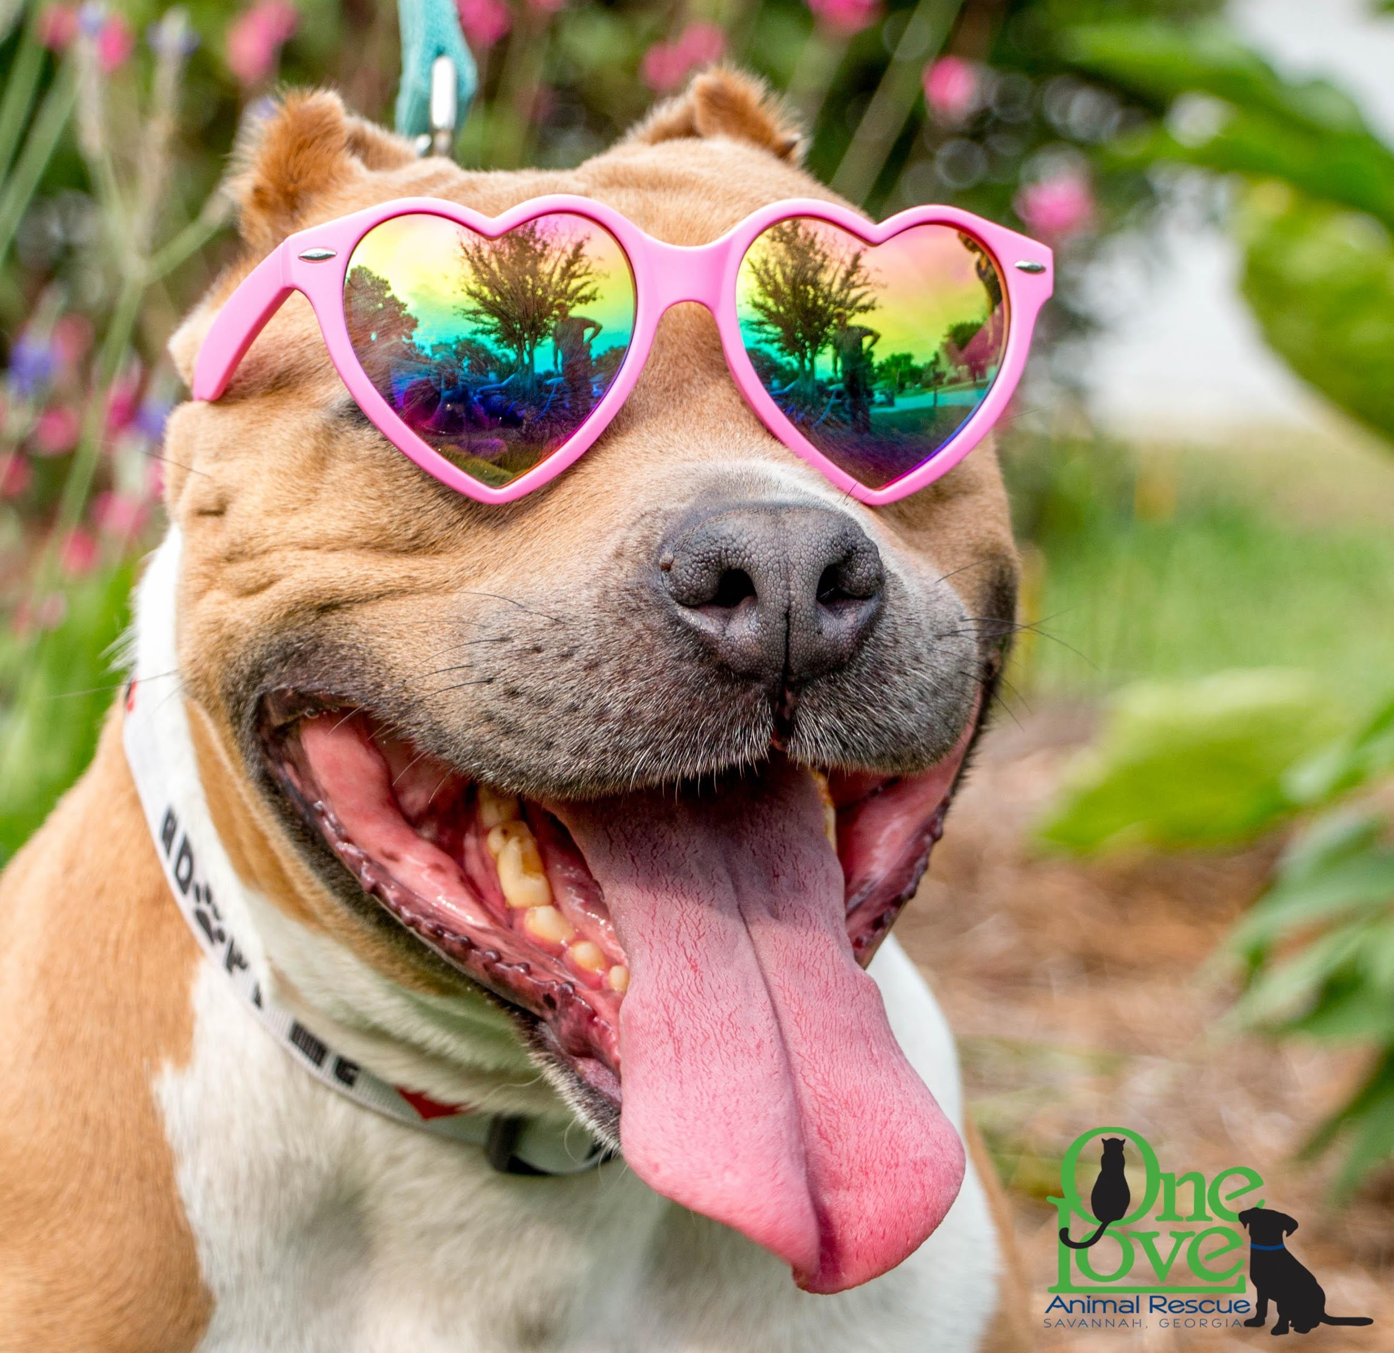
Dogs and kids can be great playmates and confidants. But children must learn proper handling and discipline, and dogs must learn self-control so that they do not play too rough. Children must be supervised and taught that dogs are beings, not dolls or toys to dress-up or be handled constantly. Teach children not to tease or rile up the dog unnecessarily. This includes chasing around the house, which can scare a dog, who may snap if cornered or frightened.

Make sure your children know that it is not the dog’s fault if the dog chews up toys or shoes that are left out. The dog should NOT be punished for such behavior, but only corrected if caught in the act. Keeping doors shut and toys put away can minimize damage. Make sure the dog has his/her own toys, and keep them in the same place all the time (like in a basket or in the dog’s crate.)

Children like the idea of caring for a dog, but the daily work of feeding, bathing, brushing, and cleaning up after the dog is not really suited for them. Recognize that the initial enthusiasm will wane quickly, and the true responsibility of caring for the dog will fall to the adults in the household. Allow them to participate with age-appropriate tasks.

Children should not play unsupervised with foster dogs. For puppies, teach proper handling (pick up by the body, not the limbs) and limit interaction. Young children should not walk foster dogs, as children cannot really handle random encounters with other animals which are bound to happen.

Children need to be taught that a puppy’s mouthing is not biting, and that the puppy is not trying to hurt them. Perhaps most importantly, children must learn to properly discipline the foster dog/puppy - a sharp “no” or “off” and remember, no hands on the dog until all paws are on the ground. Children should not engage in the squirt bottle method as they may think that squirting the dog is fun. Children often react to a dog’s bad behavior by hitting the dog, and this is UNACCEPTABLE.

Children should be monitored with foster cats as well, and the same basic principles apply. Children should be taught proper handling of the cat, given age-appropriate tasks for care of the cat, and never left unsupervised with the cat.

Medical Treatment

Prior to any medical procedure for your foster pet, you must contact the Dog Coordinator and get approval. Failure to get prior approval will mean that you forego any possible reimbursement for treatment. Even if you are willing to cover vet expenses, we prefer to have the foster pets seen by one of our approved veterinarians so that they receive consistent care and their records are centralized. If the pet is sick, injured, needs to be spayed or neutered, or needs a doctor’s visits for immunizations, the Dog Coordinator can make a vet appointment at a convenient time for you. For medical emergencies, please call immediately:

Faulkville Animal Hospital 3036 US-80, Bloomingdale, GA 31302 (912)748-7800
Karrie Bulski, Dog Coordinator (912) 596-2955
Helen Benton, Dog Foster Coordinator (912) 398-6524
Patty Davis, Cat Coordinator (912) 313-7231
Ally Cross - Babysitting Coordinator (708)439-7248

Make sure that your own pets are protected. We expect that resident pets are all spayed/neutered, and have all their vaccinations including DHPP and recommend that your dogs are immunized for Bordetella (kennel cough) since it is a common ailment among shelter dogs. We also expect that your resident pets are being treated for fleas. The Dog Coordinator will keep track of your foster dog’s/cat’s immunization records and medical treatment. We ask that you ensure that your foster dog or foster cat is treated for fleas, takes heartworm preventative and is brushed and bathed regularly.

Adoption Procedure

One Love adoption counselors work hard to find the proper match for each of our pets. This ensures that both the adopting family and the pet will be happy with the decision. All applicants must go through the One Love adoption process. Pets cannot be adopted to friends or family of the foster home without approval from One Love, and all applicants must be properly screened. It is important for you to understand our adoption procedures since you will get questions about it.

The adoption process is generally as follows:

1. The applicant fills out an Pre-Adoption Application (see website)

2. A One Love Adoption Counselor reviews the application and screens the person to see if they are a good fit; asking about where the pet will sleep, how long the pet will be left alone, what the training plans are, how they will exercise, etc.

3. The adopter and all members of their household, including resident dogs and possibly cats, must meet the animal. Adopter must provide vaccination records of all current resident pets.

4. Assuming everything is complete, a home visit is conducted to check the pet’s future living arrangements.

5. The adopter fills out an Adoption Agreement and pays the requested donation. (See website for Adoption Agreement and adoption fees.)

Pets adopted from a Foster Home are typically spayed or neutered, are up to date on vaccinations, and have had a general physical before being placed. If an animal is sick or recovering from injury, we will not place the pet until he/she has fully recovered. Since all adoptions must be handled directly by a One Love Adoption Counselor, it is important that you let us know any concerns you have about the requirements for the pet’s new adoptive home. This includes how the pet reacts with cats/children/other dogs, and any other pertinent information.

Please periodically review your foster pet’s posting on our website (www.oneloveanimalrescue.com) and let your Foster Coordinator know of any updates or changes. The Bio is intended to be truthful, but with focus on the pet’s positive attributes. We always discuss a pet’s behavior, both positive and negative, in detail with potential adopters before adoption to minimize post-adoption surprises and to reduce the possibility of rehoming the pet as well as to provide interventional assistance. We can supply a foster pet description template to help in writing their biography making sure needed information is there for our posting sites.

Adoption Events

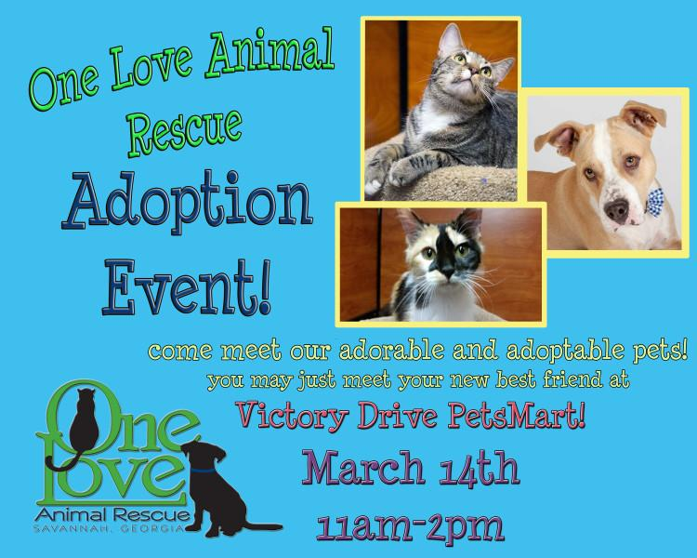
We ask that you commit to bringing your foster pet to at least two events per month, since these events are our main outlet for getting the pets adopted. Our adoption events are generally every weekend, at least one location from 11-2pm. The times and locations of these events will be posted on our website. You will receive an email each week and post on our private Facebook page from the Adoption Coordinator asking if you can attend the event with your foster pet. We may be able to arrange a handler for your foster pet if you are not able to stay at the event, but can transport the animal to the event.

If your foster dog is ill please let us know and do not bring the dog to the event. If your pet is very shy and just settling in, we may ask you to wait a week or two before attending the first event. Your pet should be up-to-date on his/her vaccinations before attending events. Check with your One Love Foster Coordinator to confirm that your foster pet is ready for adoption events.

If you are present at the adoption events and have feedback on potential adopters you speak with, please give this information to the appropriate adoption counselor. Please keep in mind that you should not make any promises or statements about the adopter’s “chances” of getting the pet. This is a topic that can get very emotional, with potential adopters getting very attached to the animals they are looking at. We try to minimize emotions by having a One Love Adoption Counselor be the only one to let potential adopters know where the animal is in the adoption process. This also minimizes miscommunication.

Before the Event:

Make sure your pet is bathed, brushed and free of fleas and ticks.

If your dog is very energetic, try to take it to the dog park or a long walk/run before the adoption event. A calm dog shows much better than a dog that is bouncing off the walls and wants to play.

Please bring your One Love leash with your dog to the adoption event. Do not bring retractable, nylon, or chain leashes. Bring a crate for your pet if possible.

Realize adoption events are stressful on your foster pet -- even pets that enjoy them are often exhausted afterwards and sleep.

Top Ten Things A Dog Handler Should Know:

Note: These are some guidelines for dog handlers during adoption events.
1. There must be one handler per dog except for puppies or small dogs that are in a pen. (If you need to take a break, ask the Coordinator or a spare volunteer to handle your dog for you.)

2. Keep your dog calm, and use a short but loose lead. The coordinator manages the mobile site and will speak to a handler that is not being attentive to his/her dog.

3. It helps reduce the stress of the dog to pet the dog slowly and talk to the dog in calm tones. When the dog is less stressed, adopters can get a better sense of the dog’s personality.

4. If you wish to introduce your foster dog to another foster dog or to a prospective adopter’s dog, introduce them one-on-one away from the other dogs. If you need help, ask the event coordinator.

5. Handlers must be aware of their dog at all times and should discourage play between animals. Play gets them excited and then they don’t appear calm for potential adopters.

6. Handlers must be aware of their surroundings, including being alert if a small child or another dog approaches. Do not allow children to put their face into the dog’s face. If someone approaches you with a dog that is showing aggression, control your dog and move out of the way.

7. Dogs that are barking should be corrected by voice, squirt bottle or other training. Dogs should not be allowed to jump on anyone.

8. Do not allow children or frail adults to walk a One Love foster dog without an escort. Do not let children handle puppies; parents can handle and allow their kids to pet them.

9. It can be helpful to have some treats in your pocket to reward your dog and to get his/her attention when a prospective adopter is near (this is especially helpful with shy dogs).

10. Dog handlers should acknowledge members of the public with a friendly greeting as soon as possible. By greeting them and introducing your dog to them, (“Hi. This is Sparky” or “Are you
looking for a dog today?”), you will increase people's recognition of and respect for One Love. Even if they are not there to adopt a pet that day, they may have friends who are interested, may be interested later, or may be willing to volunteer or donate.

Handlers of foster cats at adoption events should bring the pets in a wire crate or pen, so that they are easily visible to the public. Short events should not require bringing food or a litter pan, but a water bowl is always a good idea. Foster Homes or One Love volunteers should handle the cats while removing them from a crate. Parents can hold cats and let children pet them, but children should not handle the cats.

IMPORTANT NOTE: Adoption events are our “public relations” time. Please make every effort to chat with people who stop by even if they are not looking to adopt. Every person is important to us as a potential adopter, volunteer, donor, or for referrals for other adopters.

Reimbursement Procedure

One Love may be able to reimburse you for the following, depending on donations and sponsorships:
• Pre-approved medical expenses including vaccinations and spay/neuter
• Pre-approved flea treatment and heartworm prevention
• Other pre-approved medical expenses or supplies

Note that if you would like to donate any of the above to One Love, your donation may be tax- deductible. Please check with us regarding our 501(c)3 status at the time of your donation.

To receive reimbursement (or a receipt for tax purposes) submit an Expense Report (see Appendix) with original receipts attached to:
Karrie Bulski
karrie.bulski@gmail.com
One Love Animal Rescue, Inc.
463 Johnny Mercer Blvd. Ste B7 #142
Savannah, GA 31410

Appendix (All of our publically used forms are located on our website)
Expense Reimbursement Form
Foster Agreement - http://oneloveanimalrescue.com/foster-home-agreement/

EXPENSE REIMBURSEMENT REQUEST

Note: All receipts must be attached
Request must be received no later than 45 days from incurring expense
All expenses must have been pre-approved by Karrie Bulski or Patty Davis.

Please mail to:
Karrie Bulski
One Love Animal Rescue, Inc
463 Johnny Mercer Blvd.
Ste B7 #142
Savannah, GA 31410

Foster Name: ____________________________________
Address: ____________________________________
City, Zip: ____________________________________
Foster Cat or Dog’s Name: _____________________________________
(include all cats and dogs covered by expenses)

Please describe the type of expense:

Medical _________________ Pet Supplies _________________ Medication_________________

Total $________________ $_________________ $________________

Portion you would like to donate to One Love - $________

Total Reimbursement Request (minus donation) $_________

Foster Signature: _________________________________ Date: ________________

