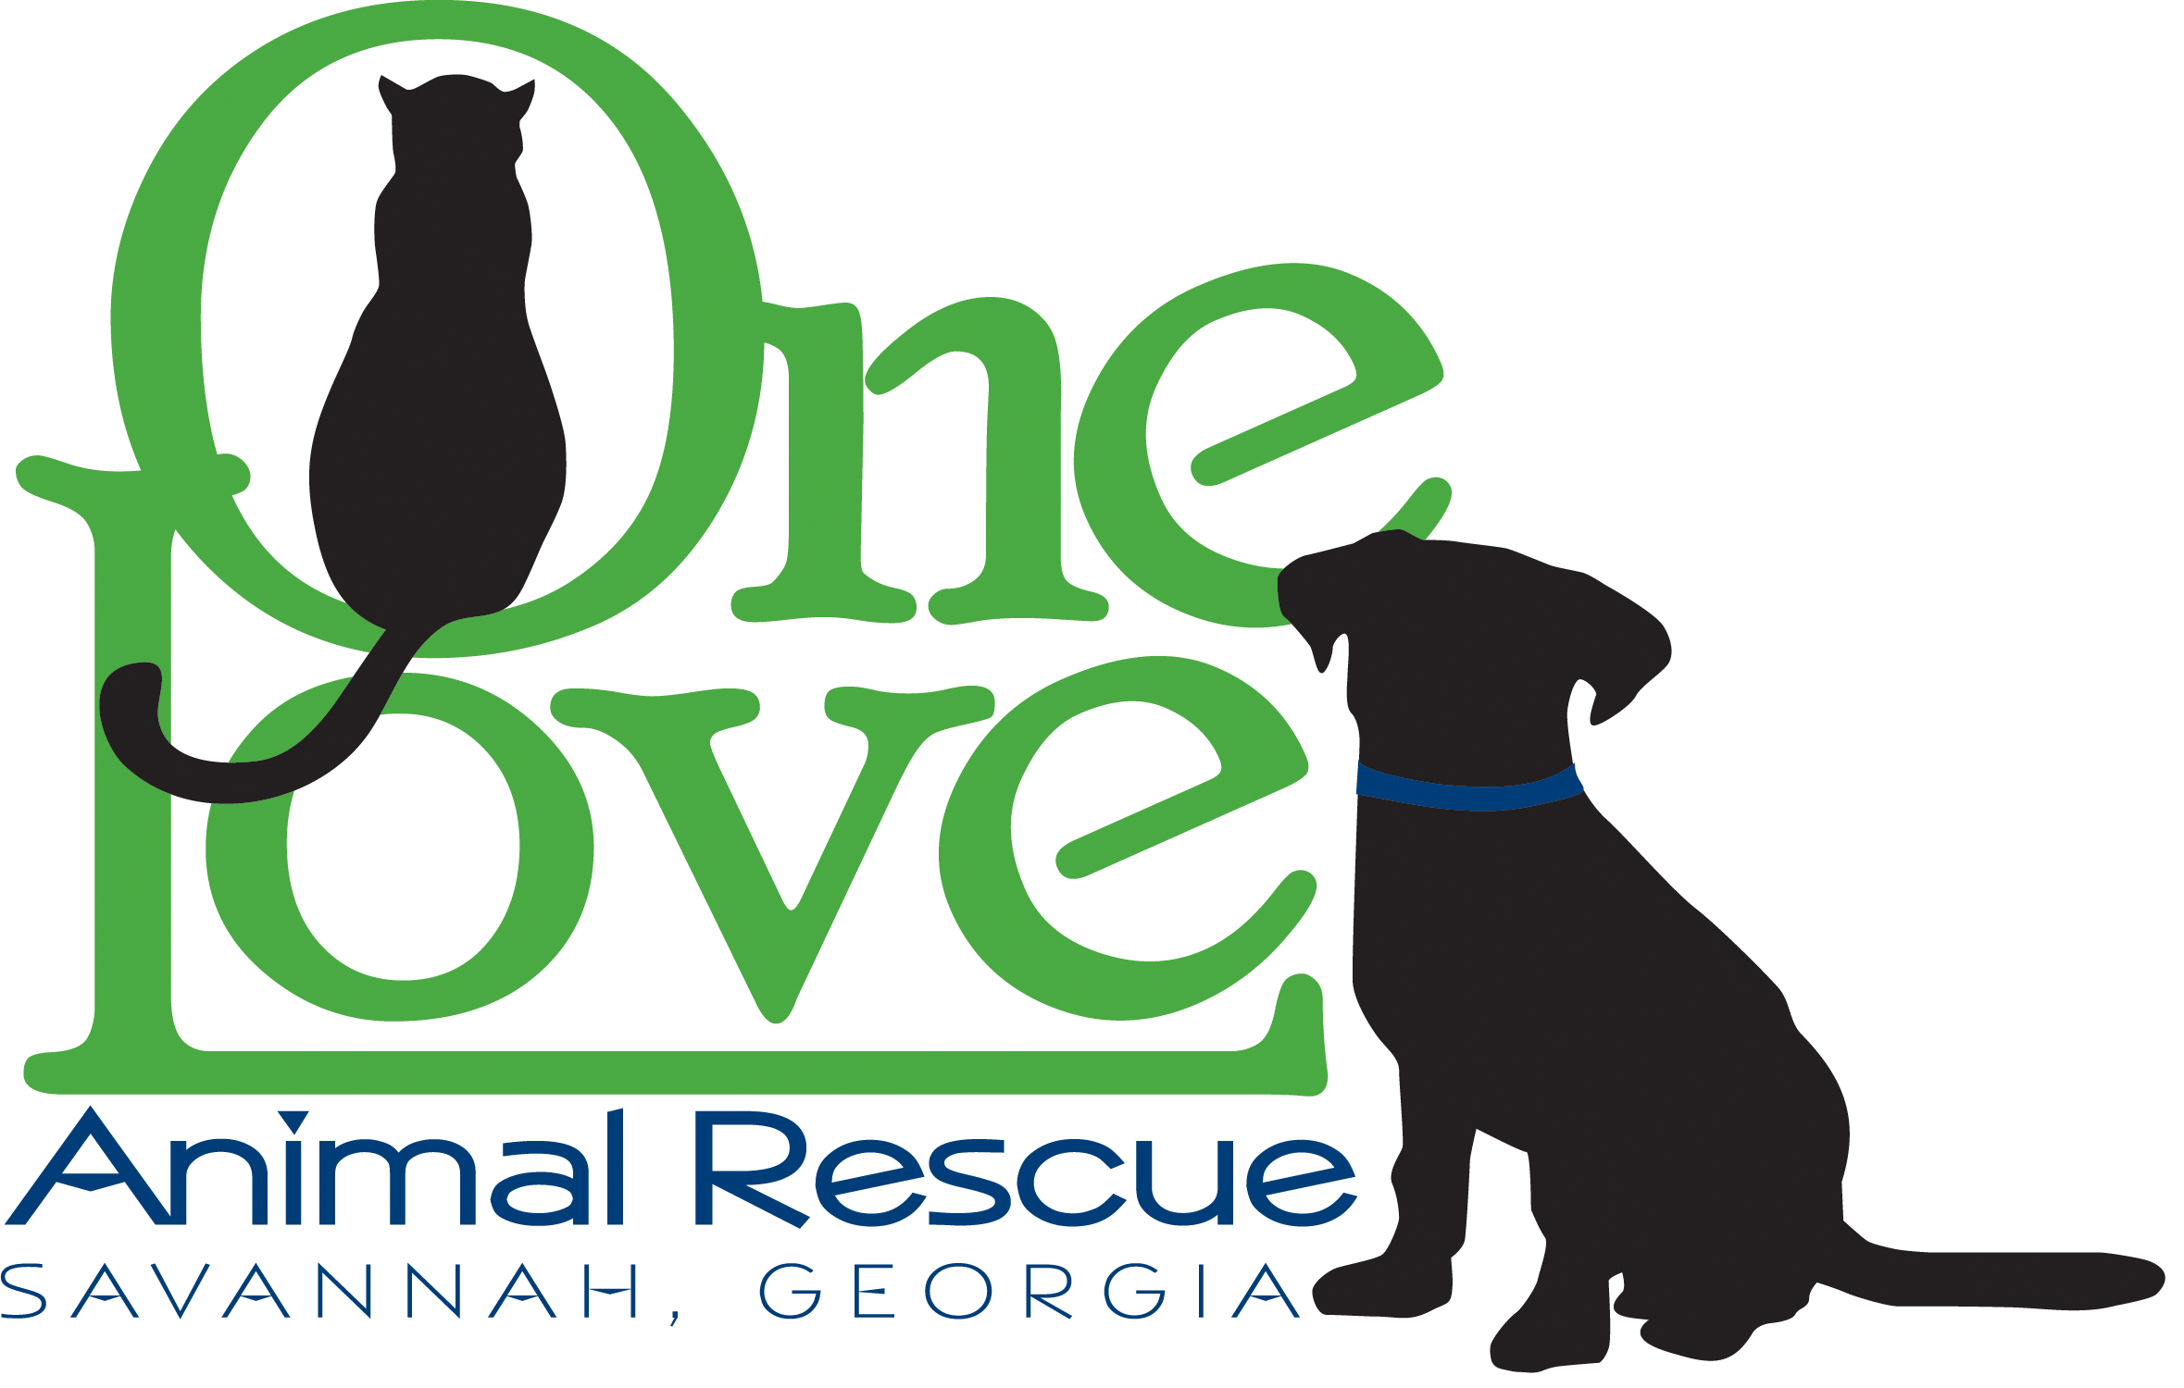

Thank you for being a foster home (“Foster Home”) for One Love Animal Rescue, Inc (“One Love”). Foster Homes like yours allow us to rescue more animals and we appreciate your generosity in opening your home to a rescued animal. By providing a foster home, you’re providing a stable, loving environment for an animal that may have been abused, neglected or abandoned. You’re also providing the much-needed socialization and basic training that will make our cats and dogs more appealing for adoption and better members of their adoptive families. One Love rescues cats and dogs from shelters and streets all over the Savannah area, as well as partners with rescue groups nationwide. Dogs must pass our temperament test in order to be pulled from the shelter and placed into a foster home. Only directors of One Love can determine which dogs our organization will accept. The animals we rescue are generally those that are in their last hours at the shelter and are at great risk of being euthanized.

General Guidelines

Please read & review the following important guidelines:

1. Prior to fostering, all Foster Homes must complete an online Foster Home Agreement and complete a home inspection. (See Appendix for Agreement)

2. All Foster Homes agree to accept primary responsibility for providing lodging and care for their foster cat or dog until a permanent adopting family is found.

3. One Love supports our foster animals 100% in vetting and supplies as long as the funds are available.

4. Medical care must be provided by a One Love approved veterinarian. If your foster pet needs any medical care, including vet visits or over-the-counter medications, please contact our One Love President Karrie Bulski. [Karrie.Bulski@gmail.com 912.596.2955]

5. Foster Homes must agree to bring their foster pet to adoption events regularly, and at least twice per month. Foster Homes must also agree to be available for appointments where potential adopters can meet the foster pet upon request and reasonable notice. NEVER invite a potential adopter to your personal residence.

6. Foster Homes must agree to keep the One Love Foster Coordinator apprised of their foster pet’s behavior and if any issues arise.

7. If you are unhappy with your fostering situation, please notify the One Love Foster Coordinator immediately. One Love will work on relocating your foster pet as soon as possible. We appreciate your patience as we remedy the situation.

8. We do not foster-to-adopt. Potential adopters must still go through our regular application process.

9. All applicants wanting a particular foster pet must go through the One Love application process (application, interview by One Love Adoption Specialist and home visit). A friend or family member of the Foster Home who wishes to adopt your foster pet must go through the same process as other applicants.

10. Your own pets (including species other than cats or dogs) should be up to date with their vaccinations. We do recommend that you vaccinate your dogs with the Bordetella vaccination to prevent kennel cough—a common illness with shelter dogs.

11. One Love is not responsible for any veterinary bills for resident pets. The Foster Home assumes responsibility for the veterinary bills that result from resident pets becoming ill due to exposure with a foster pet or any injury resulting from but not limited to, an unpleasant interaction between your resident pet and foster pet (dog fight, scratches, etc.).

12. If you are planning a vacation, please notify One Love as far in advance as possible, but at least within two weeks of the vacation date. If you want to take your foster pet with you—even for just a weekend—you MUST notify One Love beforehand and receive approval. If One Love has an applicant interested in adopting, we may make arrangements to keep your pet locally with someone else in order to show him/her.

13. Do not leave your foster pet with anyone else without prior approval from One Love. Anytime a foster animal is left with someone outside of the Foster Home we MUST have a signed release of liability.

14. ALWAYS walk your One Love foster with the harness and collar provided with the One Love tag on. This ensures that our fosters will be returned to One Love in the event they have not been microchipped yet and are picked up by animal control. We also do not condone the use of pinch or choke collars. We provide training classes each week to help fosters learn loose leash walking on a harness. Cats should always remain indoors and be transported in a secure cat carrier when put in the car or taken to the vet office.

Supplies

One Love will provide all the supplies you need to care for your foster animal. Including monthly flea and heartworm preventive for dogs and flea preventatives for cats and kittens as needed. You will receive a monthly email from Karrie Bulski letting you know when the preventives are ready to be picked up from her home [usually by the 1st of every month] 118 Candleberry Ln Savannah GA 31405.
We also provide all of the necessary food, treats, bowls, crates, bedding, toys, collar, harness, leash, litter, and litter boxes. If you are low or need replacements for any supplies contact Karrie and she will give you instructions on where and when to pick up.

Foster Dog Training Classes

One Love is proud to provide foster dog training classes that are hosted twice weekly at 2 different locations and varied times. We ask that all foster dogs over 12 weeks of age attend at minimum 2 classes per month. Training issues and poor behavior is the leading cause of animals being returned to us and into shelter so we are trying our best to be proactive. Weekly emails will be sent from the Training Coordinator asking you to RSVP to the class you’d like to attend. Instructions, supplies, locations and times can also be found on our website (http://oneloveanimalrescue.com/foster-dog-training-classes/)

Adoption Procedure

One Love adoption counselors work hard to find the proper match for each of our pets. This ensures that both the adopting family and the pet will be happy with the decision. All applicants must go through the One Love adoption process. Pets cannot be adopted to friends or family of the foster home without approval from One Love, and all applicants must be properly screened. It is important for you to understand our adoption procedures since you will get questions about it.

The adoption process is generally as follows:

1. The applicant fills out an Pre-Adoption Application (see website)

2. A One Love Adoption Counselor reviews the application and screens the person to see if they are a good fit; asking about where the pet will sleep, how long the pet will be left alone, what the training plans are, how they will exercise, etc.

3. The adopter and all members of their household, including resident dogs and possibly cats, must meet the animal. Adopter must provide vaccination records of all current resident pets.

4. Assuming everything is complete, a home visit is conducted to check the pet’s future living arrangements.

5. The adopter fills out an Adoption Agreement and pays the requested donation. (See website for Adoption Agreement and adoption fees.)

Pets adopted from a Foster Home are typically spayed or neutered, are up to date on vaccinations, and have had a general physical before being placed. If an animal is sick or recovering from injury, we will not place the pet until he/she has fully recovered. Since all adoptions must be handled directly by a One Love Adoption Counselor, it is important that you let us know any concerns you have about the requirements for the pet’s new adoptive home. This includes how the pet reacts with cats/children/other dogs, and any other pertinent information.

Please periodically review your foster pet’s posting on our website (www.oneloveanimalrescue.com) and let your Foster Coordinator know of any updates or changes. The Bio is intended to be truthful, but with focus on the pet’s positive attributes. We always discuss a pet’s behavior, both positive and negative, in detail with potential adopters before adoption to minimize post-adoption surprises and to reduce the possibility of rehoming, as well as to provide interventional assistance. We can supply a foster pet description template to help in writing their biography making sure needed information is there for our posting sites.

Adoption Events

We ask that you commit to bringing your foster pet to at least two events per month, since these events are our main outlet for getting the pets adopted. Our adoption events are generally every weekend, at least one location from 11-2pm. The times and locations of these events will be posted on our website. You will receive an email each week and post on our private Facebook page from the Adoption Coordinator asking if you can attend the event with your foster pet. We may be able to arrange a handler for your foster pet if you are not able to stay at the event, but can transport the animal to the event.

If your foster dog is ill please let us know and do not bring the dog to the event. If your pet is very shy and just settling in, we may ask you to wait a week or two before attending the first event. Your pet should be up-to-date on his/her vaccinations before attending events. Check with your One Love Foster Coordinator to confirm that your foster pet is ready for adoption events.

If you are present at the adoption events and have feedback on potential adopters you speak with, please give this information to the appropriate adoption counselor. Please keep in mind that you should not make any promises or statements about the adopter’s “chances” of getting the pet. This is a topic that can get very emotional, with potential adopters getting very attached to the animals they are looking at. We try to minimize emotions by having a One Love Adoption Counselor be the only one to let potential adopters know where the animal is in the adoption process. This also minimizes miscommunication.

Before the Event:

Make sure your pet is bathed, brushed and free of fleas and ticks.

If your dog is very energetic, try to take it to the dog park or a long walk/run before the adoption event. A calm dog shows much better than a dog that is bouncing off the walls and wants to play.

Please bring your One Love leash with your dog to the adoption event. Do not bring retractable, nylon, or chain leashes. Bring a crate for your pet if possible.

Realize adoption events are stressful on your foster pet -- even pets that enjoy them are often exhausted afterwards and sleep.

Important Contacts

Karrie Bulski - One Love President
(912) 596-2955
karrie.bulski@gmail.com

Patty Davis - Adoption Coordinator, Home Visit Coordinator, Cat Coordinator
(912) 313-7231
patty.davis95@gmail.com

Helen Benton - Foster Coordinator
(912) 398-6524
helenbenton.olar@gmail.com

Ally Cross - Babysitting Coordinator
(708)439-7248
across1@alumni.nd.edu

Faulkville Animal Hospital
3036 US-80, Bloomingdale, GA 31302
(912)748-7800

